Section Two: Calculator – 80 marks

This section has eleven (11) questions. Attempt all questions.

Suggested working time: 100 minutes

Question 9: [4 marks]
Vectors and are as follows: 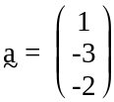 and 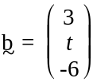. Determine the value of t if 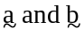 are:

a) Parallel to each other.



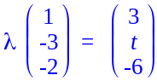

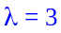

 ✓

[1]

b) Perpendicular to each other.

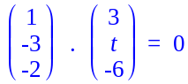 ✓

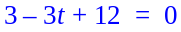 ✓



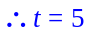 ✓

[3]

Question 10: [6 marks]

Prove that the square of an integer NOT divisible by 5 leaves a remainder of 1 or 4 when divided by 5.

Let integer n = 5x + a, where a = 0, 1, 2, 3, 4. ✓

Case 1: n = 5x Case 2: n = 5x + 1

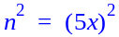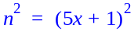

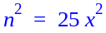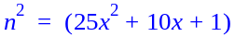

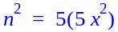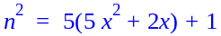

Multiple of 5 not considered ✓ Remainder of 1, when (or if n = 5x is not included) divisible by 5

Case 3: n = 5x + 2 Case 4: n = 5x + 3

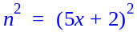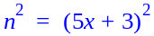

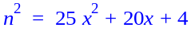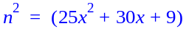

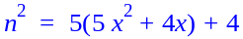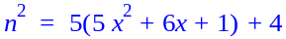

Remainder of 4, when Remainder of 4, when divisible by 5 divisible by 5

Case 5: n = 5x + 4

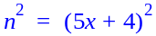

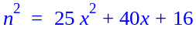

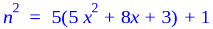

Remainder of 1, when
divisible by 5

✓ Logical presentation
✓ All cases considered
✓ Working
✓ Statement about remainders and divisibility (at end of each or overall)

[6]

Question 11: [6 marks]
Determine the equations of A, B and C from the graph below:

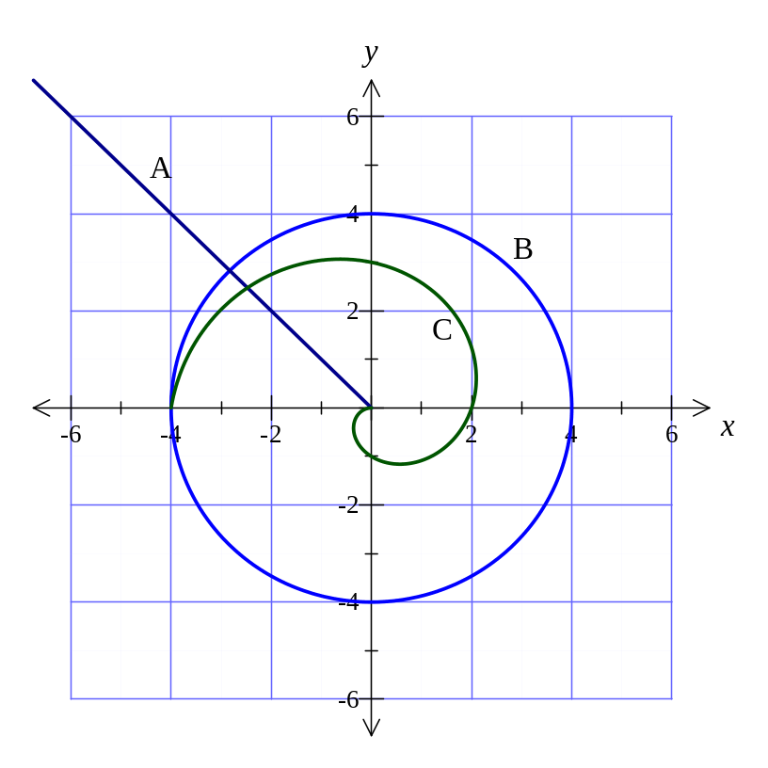

A = 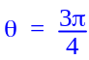 ✓✓ or 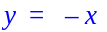 ✓  ✓

B = 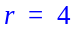 ✓✓ or ✓ 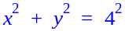 ✓

C = 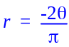 ✓✓

[6]

Question 12: [9 marks]
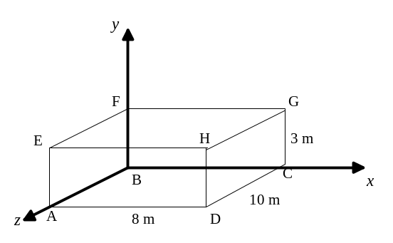
The diagram on the right shows a rectangular prism.

Determine:

a) 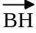  ✓

[1]

b) 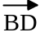  ✓

[1]

c) 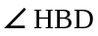 (in degrees, to 1 decimal place).
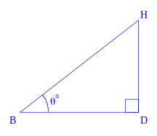
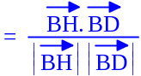

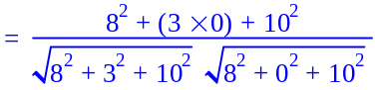

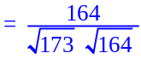 ✓✓

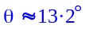 ✓

[3]

d) The acute angle between the skew lines BD and FE.

 ✓
 ✓

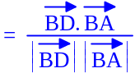
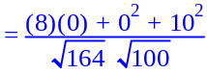
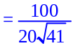 ✓

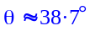 ✓

[4]

Question 13: [4 marks]

Prove the following:

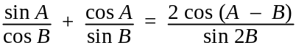.

RHS 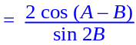

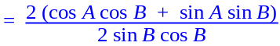 ✓✓

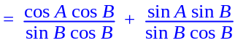 ✓

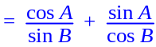

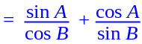 ✓

= LHS

∴ Proved

[4]

Question 14: [4 marks]
Use calculus techniques to determine: 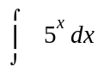.

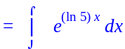 ✓✓

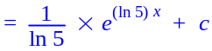 ✓

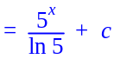 ✓

[4]
Question 15: [11 marks]

ABCD is a parallelogram with points E and F such that 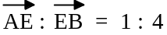 and 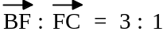.  and 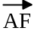 intersect each other at G. Let: 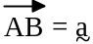 and 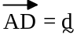.

a) Complete the diagram below with the information given above.
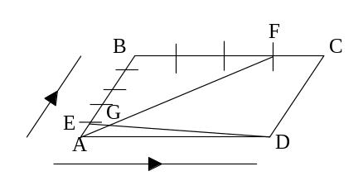

✓✓ (-1 each mistake)

[2]

b) Determine the ratios in which and intersect each other, if the intersection point is at G.

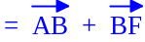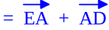

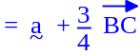 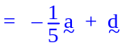 ✓

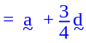 ✓

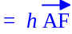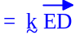

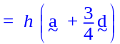 ✓ 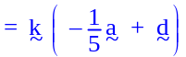 ✓



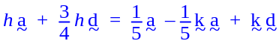 ✓

 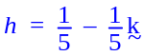 (Equation 1)
✓
 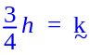 (Equation 2) 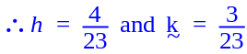 ✓

 ✓

 ✓

[9]
Question 16: [15 marks]

If: a = <8, -6, 0> and b = <-2, 4, -1>, determine:

a) 2b – a

 ✓
[1]

b) A vector in the same direction as a but equal in magnitude to b.

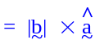

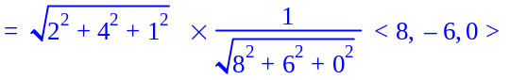
✓
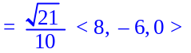 ✓
✓

[3]

c) The acute angle that vector a makes with the y-axis.

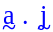 ✓

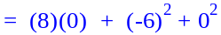

= 36 ✓

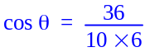 ✓

 ✓

[4]
Question 16 cont…

d) Point P lies on the line AB (from 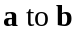) and it is known that: 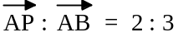. Determine the position vector of the point P.

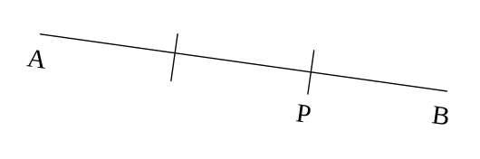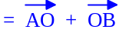

 ✓

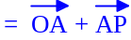

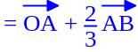
✓

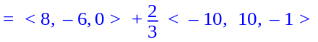 ✓

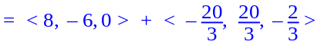

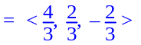 ✓

[4]

e) If: c = <6, 5, -2> and d = <-10, -38, 11>, express d in the form: 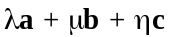, and hence determine 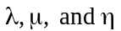. (Hint: Use the vectors a and b from the start of the question).

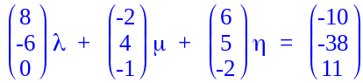 ✓

Simultaneous equations:

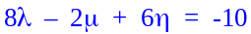
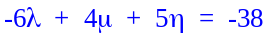


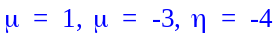 ✓

 ✓

[3]

Question 17: [7 marks]

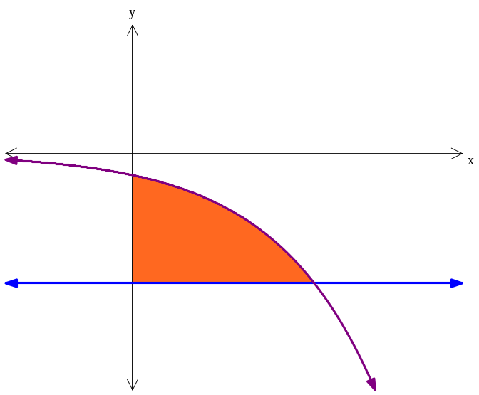
The graphs of 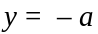 and 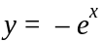 are shown below:
y = -a
y = -e^{x}

a) Write an expression for the shaded area (above), in the form: 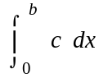.
✓
✓
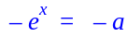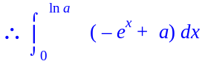
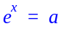 ✓
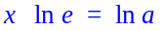
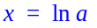
[3]

b) Determine the values of a and b, if it is known that: 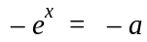, when
x = 1⋅7918.

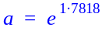 ✓
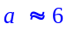 ✓

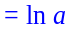
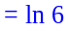
 ✓

[3]

c) Determine the area of the shaded region (to two decimal places).

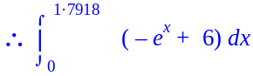

 ✓ (-1 overall if no units)
[1]
Question 18: [14 marks]

The two countries Zedlandia and Xenutia are at war. Zedlandia (z) fired a ground to air missile in order to intercept a missile coming in from Xenutia (x). When z was launched, the position vectors (in metres), relative to the army base were:

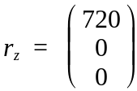 and 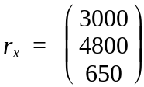.

Both z and x have constant velocities (m/s):

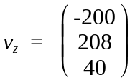 and 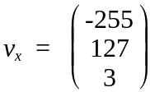.

a) Prove that the two missiles did not intercept.

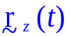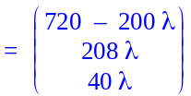
✓
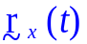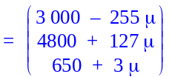

✓
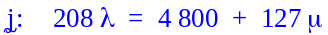

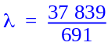 and 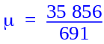 ✓

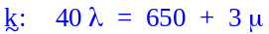

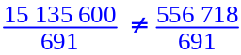 ✓

∴ Missiles do not intersect

[4]

Question 18 cont…

b) Determine by how much (distance and time) the two missiles missed each other (Note: Enough working must be shown in order to gain full marks).

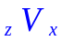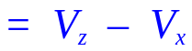
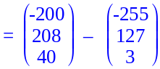
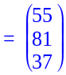 ✓

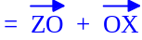
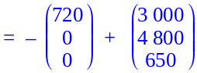
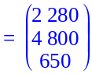 ✓

Let P be the point that is on Z and forms the shortest distance between the missiles.

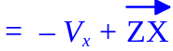
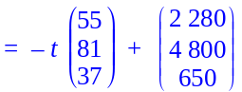
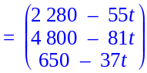 ✓

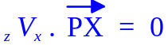
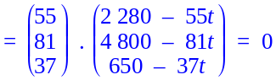

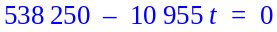

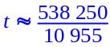
 ✓

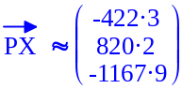 ✓

 ✓

(-1 overall if no units)
[6]

Question 18 cont…

c) In order for the two missiles to collide, the z missile changed its flight plan after 15 seconds. The x continued on its path and then interception occurred 25 seconds later. Determine the constant velocity that z maintained in this second stage for interception to occur.

Method 1: Method 2:

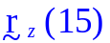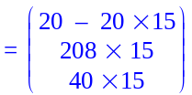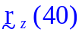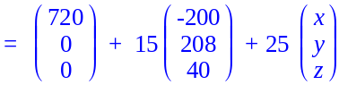

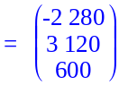 ✓ 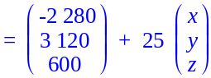 ✓

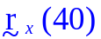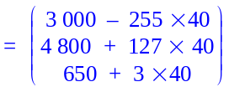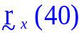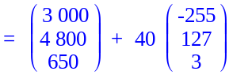
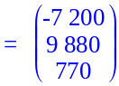 ✓ 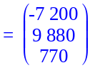 ✓

At collision =

= - + 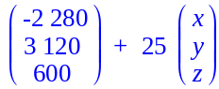 ✓

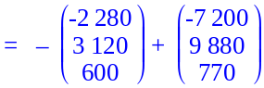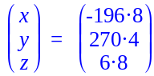

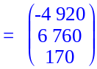 ✓ 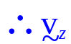 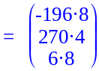 m/s ✓

V =

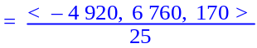

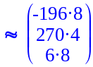 m/s ✓

(-1 overall if no units)

[4]

END OF EXAM

